**Real Time Embedded Systems**

# **Lab # 08**



|  |  |
| --- | --- |
| Name | Arwa Amir |
| Registration Number | FA16-EEE-002 |
| Class | EEE-8 |
| Instructor’s Name | Dr. Ahsan Malik |

**Task 2:**

**Arduino Code:**

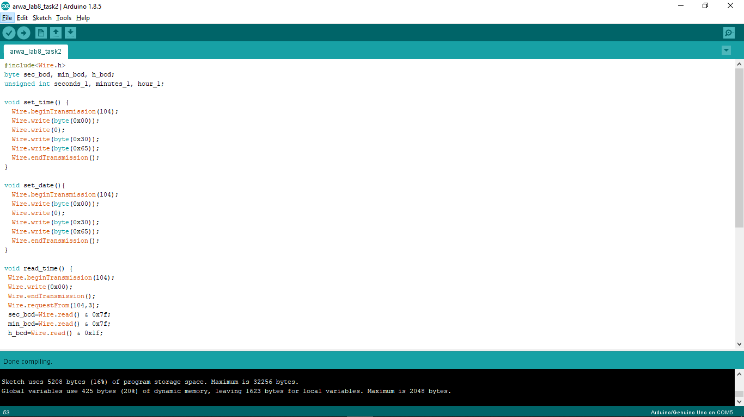

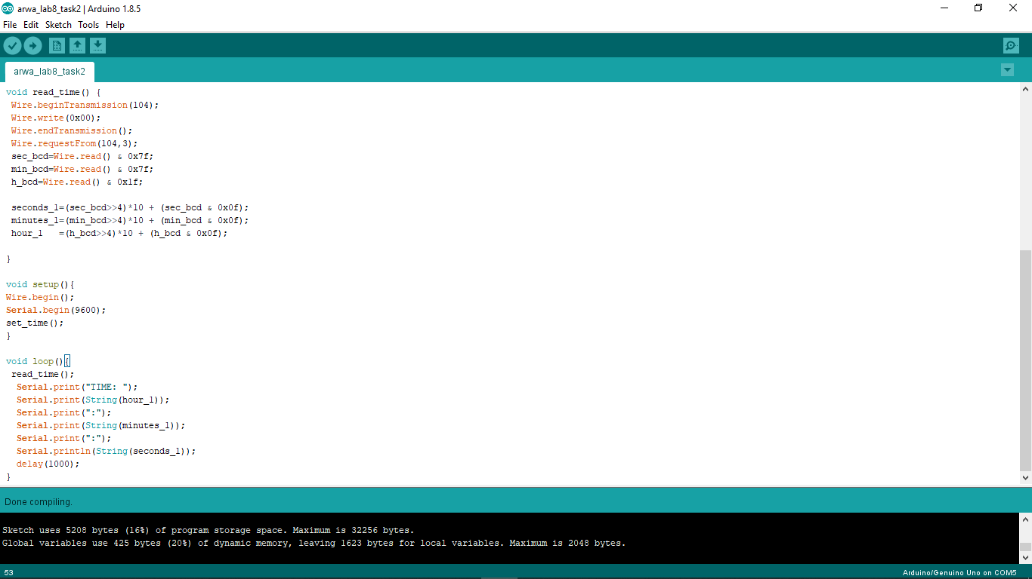

**Proteus layout:**

